Hunter Schools Dance Festival
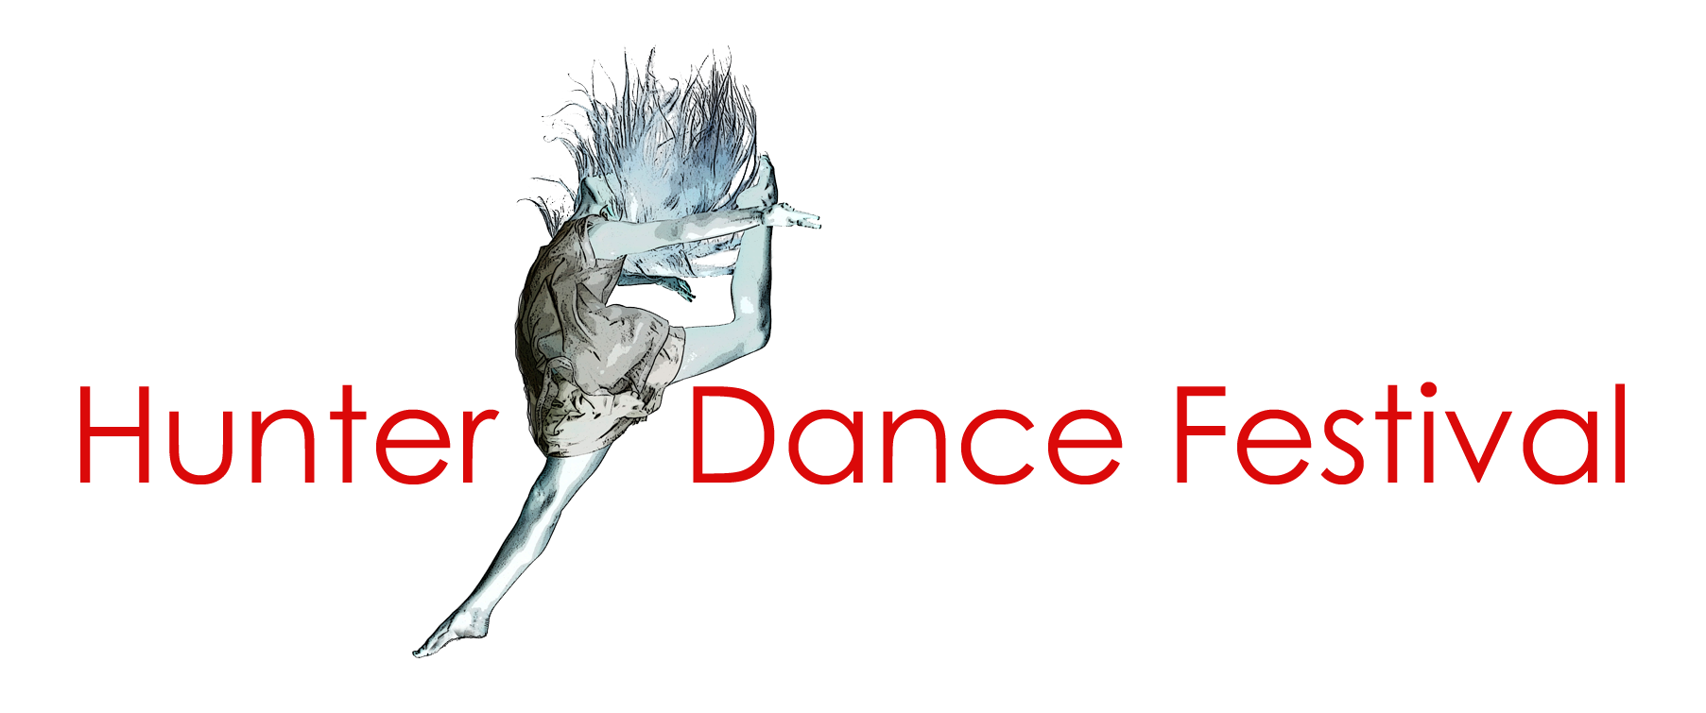

Key information
All public schools K-12 are invited to audition for the Hunter Schools Dance Festival.

Festival aims
- Demonstrate dance syllabus outcomes
- Encourage and showcase excellence in dance education
- Provide opportunities for students to develop skills and experience performing at a professional venue.

Audition guidelines

Item selection criteria
- Choreography that is appropriate for the students’ age and performance to a general audience.
- Demonstration of dance syllabus outcomes.
- Demonstration of technical skills and safe dance practices.
- Performance quality, originality and cohesive representation of a concept.

Please note
- Suggestive costumes, movements or music or simulated violence will not be selected.
- Popular pieces of music or songs may disadvantage groups for selection if several dances use the same music.
- If schools have been selected for more than one dance, we cannot guarantee that all selected dances will appear in the same performance night.

If you have any questions about preparing your audition, please email the festival committee at hunterdancefestival@det.nsw.edu.au.

Item format
- Items must be 3 minutes in duration.
- Include between 8 and 30 students (no individual performances). Students can only perform in one audition item.
- We can only accept complete dance routines.

Staging
- No glitter, talcum powder or paper. These will not be allowed at the performance venue.
- Props must be able to be set up and removed within 20 seconds. Please note that there is no room for prop storage at the venue.
- Wests Newcastle theatre stage dimensions – 16m x 9m.

Costumes
- Costumes do not need to be complete for the audition.
- Schools must indicate the proposed costume. You may upload a sketch, description or video of a student wearing a prototype in the online application.
- Schools are encouraged to wait to confirm selection for the festival before creating new costumes.

Filming
- Please film the complete dance routine.
- The video must show all students who will perform at the festival.
- Please make sure that you have parent/caregiver permission before filming students. This is the school’s responsibility.
- Schools must perform the same routine from the audition in the festival.
- We recommend filming a static image (filmed from a tripod) rather than zooming in or panning.
- Position the camera in the centre of the performance so that student entrances and exits are visible.
- No titles or graphics are necessary.

Successful items
- The HSDF committee will confirm all inclusions in the festival as soon as possible after auditions close..
- Successful performances must complete the online ‘offer to perform’ acceptance. This will be sent with the email to indicate if you are successful.

Festival details

Rehearsal details
- All performers must attend rehearsals.
- Rehearsals are at 12pm on the day of the performance.
- Rehearsals are in order of performance to confirm sound and lighting settings.
- Students must be in full costume and accessories.

Performance details
- Venue: NEX Newcastle Exhibition & Convention Centre, Wests, King St, Newcastle
- Times: 6:30 pm each evening.
- Access to holding rooms for the performance will open at 5:30 pm.
- There is no interval.
- No filming and photography at the venue due to copyright and club restrictions.

Supervision
- DoE teachers must supervise their students for the entire rehearsal and performance. This duty cannot be transferred to parents or volunteers.
- This is required by the Department of Education Excursion Policy (1.3, 1.4 and
- 4.3) and implementation procedures (4.2.1).
- All schools must advise parents that students can only be collected after the end of the performance session on the night.
- This is required under Wests WHS and Child Protection and is non-negotiable.
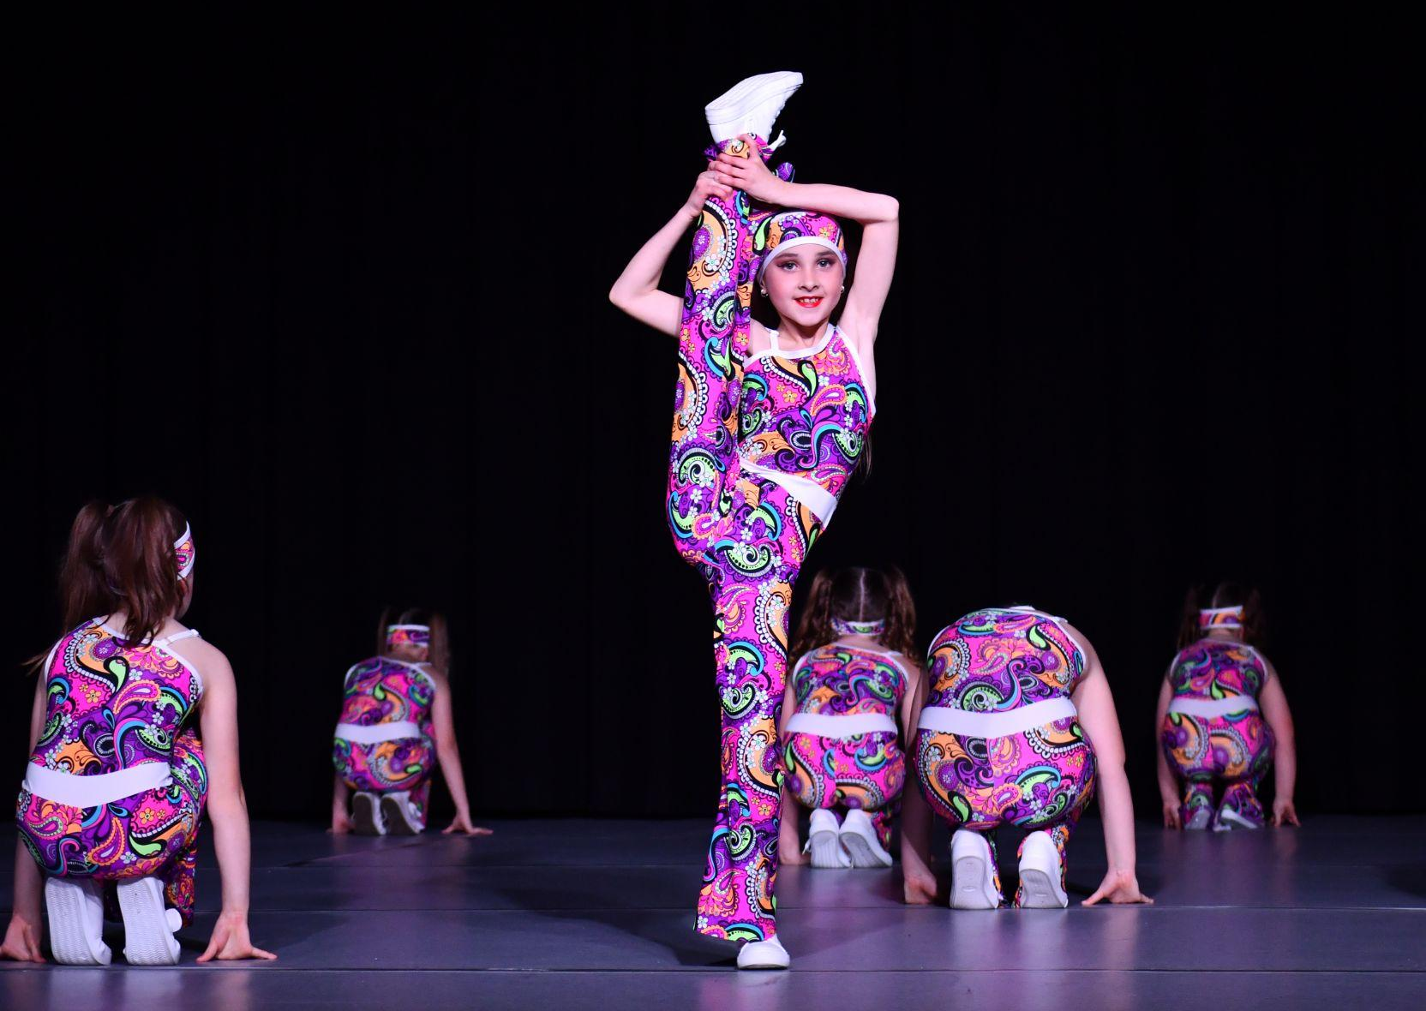

Copyright guidelines
Copyright is the individual school and teachers’ responsibility. Schools must follow copyright agreements or receive a fine. Any fines are the schools' responsibility.

How to follow the copyright agreement
- Use one (1) song for the performance (advised).
- Fade out at 3 minutes. Do not edit, cut or rejoin the song.

OR

If using more than one (1) song
- Edit the music to fade out and fade in. You must not overlap songs or edit them together.
- You must not make new arrangements, change lyrics or adapt sound recordings (in a remix or segued medley) without permission from the copyright owner
- (usually a publisher). If so, the school must seek permission from the copyright owner and pay the APRA fee (Australasian Performing Right Association and Australasian Mechanical Copyright Owners Society).

OR

If using content from a musical or show (including Disney)
- Do not portray any elements of the musical or show (including storyline or characters).
- Choose a different costume to the musical or show.
- For example, you cannot perform ‘The Circle of Life’ from The Lion King with students in animal costumes.

If you are outside the copyright agreement
- If you create an item or use music that does not follow the above guidelines, you will need permission from the copyright holder.
- Consider music choices carefully as permission can take up to eight weeks to be granted.
- To apply for performance approval and copyright, contact APRA at email: schools@apra.com.au.

You can also seek help from The Copyright Unit (via DoE intranet) which advises schools on copyright issues, email: copyright@det.nsw.edu.au, telephone: 02 9561 1204.

DoE intranet: https://education.nsw.gov.au/inside-the-department/legalservices/legal-topics/governance-and-commercial/copyright.

